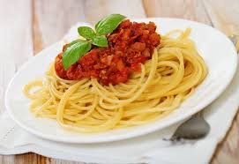

# *Written* 100 marks

# *Practical* 20 marks

*Processes and Production Skills* 30 marks

**Total 150 marks**

*30 % of semester mark*

Pasta Task

Name:

Teacher:

Class:

Class:

**Design Challenge:**

Your task is to investigate pasta and completed pasta dishes. Through research and practice, you will be asked to create your own pasta dish, in your group, using the available ingredients. This dish you create will need to be a sample of what would be an acceptable meal to serve at a family dinner. You will then need to evaluate your production processes and how well your dish would suit the criteria.

**You will be assessed on the following criteria:**

**Knowledge and Understanding**

Analyse how characteristics and properties of food determine preparation techniques and presentation when designing solutions for healthy eating ([ACTDEK033](https://connect.det.wa.edu.au/group/staff/resources/curriculum?learningarea=Technologies&subject=Design%20and%20Technologies&__clnssluui=9d7qoyeqtmj3wxpqa))

|  |
| --- |
| Teacher Comment |
| __________________________________________________________________________________________________________________________________________________________________________________________________________________________________________________________________________________________________________________________________________________________________________________________________________________________________________________________________________________________________________________________________________________________________________________________________________________________________________________________________________________________________________________________________________________________________________________________________________________________________________ |

**Processes and Production Skills**

Critique needs or opportunities for designing and investigate, analyse and select from a range of materials, components, tools, equipment and processes to develop design ideas ([ACTDEP035](https://connect.det.wa.edu.au/group/staff/resources/curriculum?learningarea=Technologies&subject=Design%20and%20Technologies&__clnssluui=9d7qoyeqtmj3wxpqa))

**Investigate**

1. **ICT:**

To complete this question, you will need access to the Get Work folder. Complete the question as a word document then submit to your teacher separately.

**33 marks**

1. **Pasta Tasting**

Evaluate the flavour, texture, appearance, length of cooking time, cost, and ingredient composition of dried and fresh commercial pasta.

|  |  |  |  |  |
| --- | --- | --- | --- | --- |
| Pasta Type | Flavour  Texture  Appearance | | Cooking Time – How long did the pasta take to get to the al dente stage? | Cost |
| Dried Pasta | F |  |  |  |
| T |  |
| A |  |
| Fresh Pasta | F |  |  |  |
| T |  |
| A |  |

**10 marks**

1. Work out the cost of each pasta type.

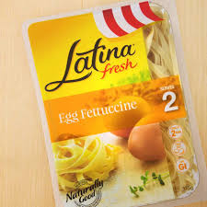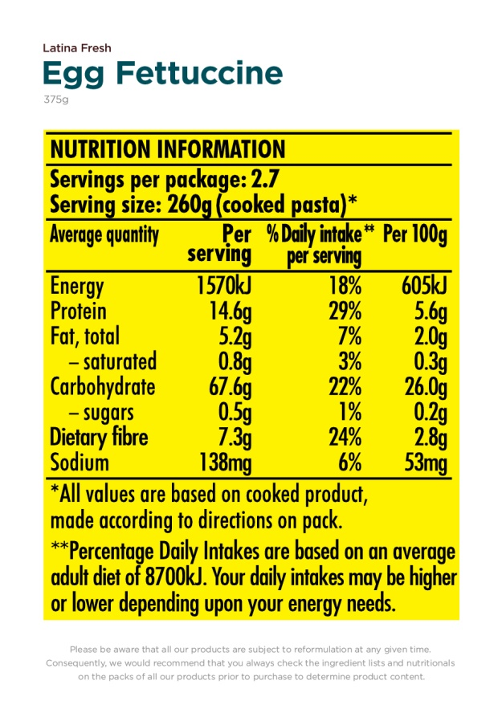

Price per kilo = $13.70

Amount used per serve = 130g

Price for 130g fresh pasta: (13.70/1000) x 130g = _________________________

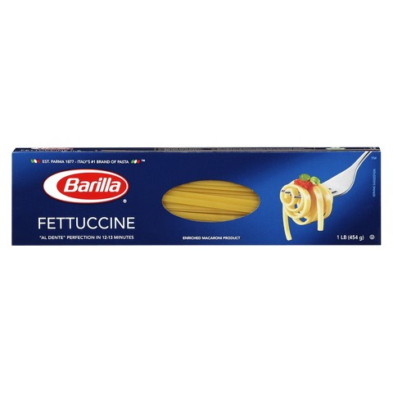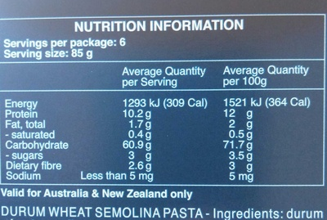

Price per kilo = $4.20

Amount used = 85g

Price for 85g dried pasta: (4.20/1000) x 85g = _________________________

**2 marks**

1. Which of the two types of pasta is the best value for money? Why?

______________________________________________________________________________________________________________________________________________________

**2 marks**

1. Compare the flavour, texture and appearance of the two pastas. Explain, with reasoning, which is best. ____________________________________________________________________________________________________________________________________________________________________________________________________________________________________________________________________________________________________________

**3 marks**

1. Which pasta has the least cooking time? How does this affect upon the environment? _________________________________________________________________________________________________________________________________________________________________________________________________________________________________

**2 marks**

1. List the nutrients found in each type of pasta.

|  |  |
| --- | --- |
| **Fresh** | **Dried** |
|  |  |

**4 marks**

1. The main nutrient found in pasta is ___________________________ and it provides your body with _____________________.

**1 mark**

1. Taking into account all of the above questions, which is the better pasta to suit **your** needs? Explain your answer using examples. __________________________________________________________________________________________________________________________________________________________________________________________________________________________________________________________________________________________________________________________________________________________________________________________________________________________________________________________________

**2 marks**

1. Find three pasta recipe from cooking books or the internet. Complete a Plus, Minus and Interesting chart (PMI) for each recipe. Consider the following points when completing your chart:

* Type of protein used
* Type of vegetables used – colours and flavours
* Sauces
* Is it easy to cook?
* Do you understand all the terms used in the recipe?
* Is it healthy?
* Does it look nice? Why?
* Are the ingredients available to use in your dish? Look at the food order page to see the list.

|  |  |  |
| --- | --- | --- |
| **Pasta PMI** | | |
| **Recipe 1: Source:** | | |
| Plus | Minus | Interesting |
|  |  |  |
| **Recipe 1: Source:** | | |
| Plus | Minus | Interesting |
|  |  |  |
| **Recipe 1: Source:** | | |
| Plus | Minus | Interesting |
|  |  |  |

**6 marks**

**Devise**

1. Design a Pasta Dish!

With all your new knowledge about how to create a pasta dish, look at the list below, a **discuss with your group members** to create your own pasta dish or use a recipe to recreate one. Only the ingredients listed below can be used.

**Highlight** or underline the ingredients you intend to use and transfer these items to the food order sheet. Remember that you will only need **one** meat and **one** pasta product. You should also **include** 2-4 vegetables that you like.

These quantities are for one person so you will need to **adjust the quantities** to suit the number of people in your group. (ie. If you have two people in your group, you will need to **double** the quantity to be ordered.)

|  |  |  |  |  |
| --- | --- | --- | --- | --- |
| **Cereal (40g)** | **Meat** | **Vegetables** | **Grocery & Dairy** | **Herbs** |
| Spaghetti  Fettuccine  Macaroni  Penne | ½ chicken thigh  50g tuna  50g beef mince  1 slice bacon | ¼ onion  1 clove garlic  ¼ celery stalk  ¼ carrot  1/6 zucchini  2 mushrooms  1/8 capsicum  2 fl. Broccoli  1 spring onion  1/3 c tinned tomato  ¼ c corn  ¼ c peas | 2T oil  2T flour  1t sugar  ¼ t vegetable stock  ½ t mustard powder  1T tomato paste  1 egg  ¼ c cream  2T parmesan  2T cheddar  2T margarine | 2 t basil  2 t parsley  2 t oregano |

|  |  |
| --- | --- |
| **Food order** | **Equipment** |
|  |  |
|  |  |
|  |  |
|  |  |
|  |  |
|  |  |
|  |  |
|  |  |
|  |  |
|  |  |
|  |  |
|  |  |
|  |  |
|  |  |

**5 marks**

1. Write out a time plan that you can work from to create your dish. It must include **all** the steps required on the day.

Consider the following:

* How will you prepare your ingredients? Will you slice, dice, grate or shred them?
* How will you cook your pasta? Time? Temperature? Cooking equipment?
* How long will each step take? How will you when know it is ready?

**Recipe Name __________________________**

|  |  |
| --- | --- |
| **Time** | **Method** |
|  |  |
|  |  |
|  |  |
|  |  |
|  |  |
|  |  |
|  |  |
|  |  |
|  |  |
|  |  |
|  |  |
|  |  |
|  |  |
|  |  |
|  |  |
|  |  |
|  |  |
|  |  |
|  |  |
|  |  |
|  |  |
|  |  |
|  |  |
|  |  |
|  |  |
|  |  |

**10 marks**

**Produce**

1. Produce your dish using the time plan to ensure you are on task and on time.

**20 marks**

**Evaluate**

1. Describe the **appearance, flavour** and **texture** of your pasta dish.

|  |  |
| --- | --- |
| **Appearance**  What did it look like? Consider colours, shapes and presentation. |  |
| **Flavour**  What did it taste like? Was it burnt, sweet, savoury? |  |
| **Texture**  What did it feel like? Was it soft, hard, crunchy? |  |

**6 marks**

1. Did you like your meal overall? Explain your answer. _______________________________________________________________________________________________________________________________________________________________________________________________________________________________________________________________________________________________________________________________________________________________________________________

**2 marks**

1. If you were to make this meal again, what changes could you make to improve the taste, appearance and/or texture? __________________________________________________________________________________________________________________________________________________________________________________________________________________________________________________________________________________________________________________________________________________________________________________________________________________________________________________________________

**2 marks**

1. Circle the phrase that best describes you pasta dish.

* Not very healthy
* Healthy
* Very healthy

Support your choice by drawing and labelling the Healthy Eating Pyramid below and placing the ingredients you used in the correct place.

**3 marks**

1. What sort of meal would time would your pasta dish be suitable for? Explain your answer. ____________________________________________________________________________________________________________________________________________________________________________________________________________________________________________________________________________________________________________

**1 mark**

1. Did you have any problems when making your pasta dish? Explain. _______________________________________________________________________________________________________________________________________________________________________________________________________________________________________________________________________________________________________________________________________________________________________________________

**2 marks**

1. Give three (3) examples of how you used teamwork and cooperation when making your breakfast. Explain why these were important. 1._____________________________________________________________________________________________________________________________________________________2._____________________________________________________________________________________________________________________________________________________3._____________________________________________________________________________________________________________________________________________________Explain:______________________________________________________________________________________________________________________________________________________________________________________________________________________________________________________________________________________________________

**4 marks**

**Assessment Criteria – Pasta Task**

**Knowledge and Understanding**

Analyse how characteristics and properties of food determine preparation techniques and presentation when designing solutions for healthy eating

|  |  |  |  |  |  |  |
| --- | --- | --- | --- | --- | --- | --- |
| **Knowledge and Understanding = 120 marks** | | | | | | |
|  | **Investigates issues, values, needs and opportunities** | | | | | **My mark** |
| **Investigating** | * Incomplete or no attempt at ICT investigation. Support required.   **Q 1 (0-11)**   * Little to no evaluation of pasta tasting. **Q 2 (0-3)** * Basic or no completion of pasta costing and comparison. **Q 3-9 (0-5)** * Basic completion of PMI. **Q10 (0-2)** | * Completion of ICT task using basic ‘cut-paste’ methods. Some assistance required. **Q 1 (11-22)** * Completion of pasta tasting with some comparison detail. **Q 2 (4-6)** * Completion of pasta costing and comparison with some detail.   **Q 3-9 (6-10)**   * Some detail provided in PMI. **Q7 (3-4)** | | * Detailed completion of ICT investigation including only relevant information using their own language to interpret their findings. **Q 1 (22-33)** * Detailed evaluation of pasta tasting.   **Q 4 (6-10)**     * Detailed completion of pasting costing and comparison. **Q 3-9 (11-16)** * Detailed completion of the PMI.   **Q7 (5-6)** | | **/65** |
|  | Devises and generates ideas and preparing production proposals | | | | | My mark |
| **Devising** | Attempted or limited basic ingredient & equipment list and time plan **Q 11-12 (0-5)** | | Completes a basic ingredient & equipment list and time plan **Q 11-12 (5-10)** | | Correctly completes a ingredient & equipment list and time plan **Q 11-12 (10-15)** | **/15** |
|  | **Produces solutions and managing production processes** | | | | | **My mark** |
| **Producing** | * Works with assistance using basic techniques, safely and hygienically to produce their recipe.  **Q13 (0-7)** | | * Works safely, hygienically and efficiently to produce their recipe using correct techniques with little assistance. **Q13 (8-13)** | | * Works safely, hygienically and efficiently to produce their breakfast with no assistance. **Q13 (14-20)** | **/20** |
|  | **Evaluates intentions, plans and actions** | | | | | **My mark** |
| **Evaluating** | * Basic evaluation of produced food is completed. **Q 14-18 (0-5)** * Basic evaluation of team skills   **Q 19-20 (0-2)** | | * Evaluation of dish production is completed with some detail.   **Q 14-18 (5-10)**   * Evaluation of team skills is completed in some detail **Q 19-20 (2-4)** | | * Assesses their recipe and the production process answering all questions in detail. **Q 14-18 (10-14)** * Evaluation of team skills with detailed explanation.   **Q 19-20** **(4-6)** | **/20** |
| **Total for Knowledge and Understanding out of 120 marks** | | | | | | **/120** |

**Assessment Criteria – Pasta meal**

#### Processes and Production Skills

Critique needs or opportunities for designing and investigate, analyse and select from a range of materials, components, tools, equipment and processes to develop design ideas

|  |  |  |  |  |
| --- | --- | --- | --- | --- |
| **Processes and Production Skills = 30 marks** | | | | |
| **The Nature of Materials** | **Understands the properties and nature of materials** | | | **12 marks** |
| * Basic or limited attempt at choosing suitable ingredients for a pasta dish. Support required. **(0-5)**   . | * Sound attempt at choosing suitable ingredients for pasta dish. One or two components may be forgotten or not used during production. Some support or guidance required. **(6-9)** | * Correct and extensive ingredient choices made to produce a pasta dish suitable for a family dinner. No support required. **(10-12)** |  |
| **The selection and use of Materials** | Applies understanding of the nature of materials when selecting and using materials to meet technology needs | | | 18 marks |
| * Uses a basic range of techniques to complete their pasta dish. Presentation of pasta needed assistance.   **(** **Practical lessons) (0-6)** | * Showing evidence that correct techniques are used for the preparation of their pasta dish. Presentation of pasta is acceptable and balanced.   **(** **Practical lessons) (7-13)** | * Able to manage a range of techniques & equipment to produce a final product relevant to the pasta dish of choice. Presentation of dish is visually appealing.   **(** **Practical lessons) (14-18)** |  |
| **Total for Processes and Production out of 30 Marks** | | | | **/30** |

|  |  |  |  |
| --- | --- | --- | --- |
| **My Results** | **Possible Mark** | **My Score** | **Comments** |
| **Knowledge and Understanding** | **120** |  |  |
| **Processes and Production** | **30** |  |  |
| **Total** | **150** |  |  |
| **Total** | **30** |  |  |